**Type Script**

Typescript is made top up of java script means internally it use java script only to run.

In java script issues are identified in runtime so typescript comes into action typescript is a compile time and typescript have more actions compare to java script.

Variables

// var

// re declare

var num:number=20;

var num:number=30;

// re assigned

var num1:number=20;

num1=40;

// let

// re declare is not possible but re assign is possible

let num2:number=30;

num2=40;

// const

// re declare and re assigned is not possible

const num3:number=40;

Declaring variables in type script in different ways

1. Both type and initial value

Var employee:string=”imran”;

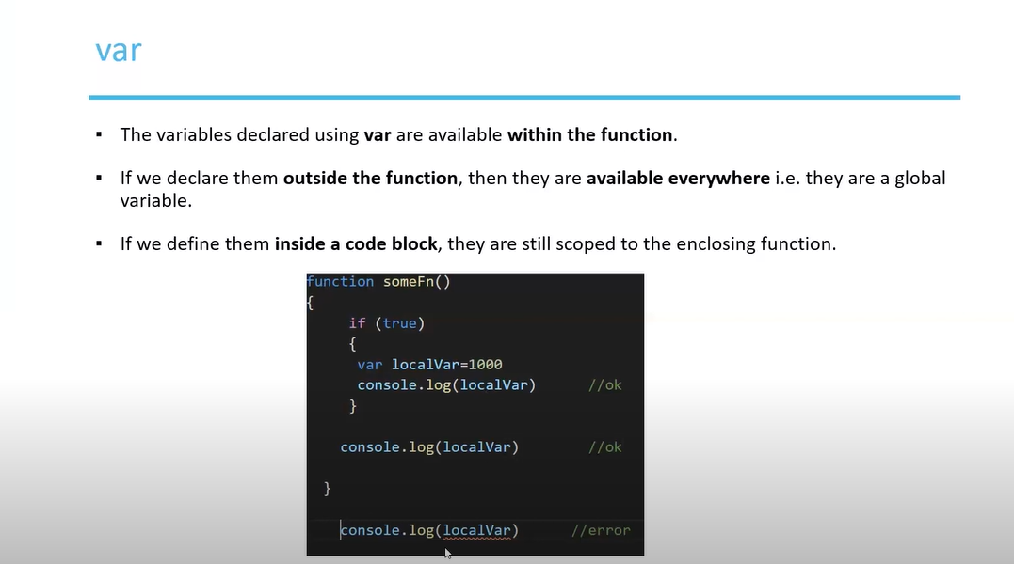

Var variables can be accessed within the functions block outside the block it cant be accessed.

If we declared var outside the block we can accessed any where like global variables, if we declared inside block we can use within the block

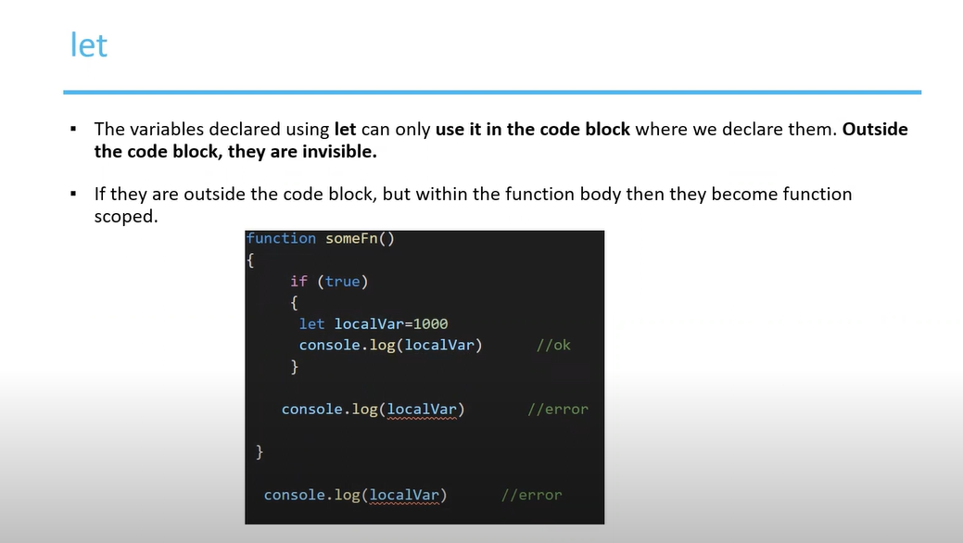

let variables can be declared with the block only we cant accessed outside the block also.

If we make let as global variables we can accessed any where.

Data Types

Operators

Conditional Statements

Looping Statements

Arrays

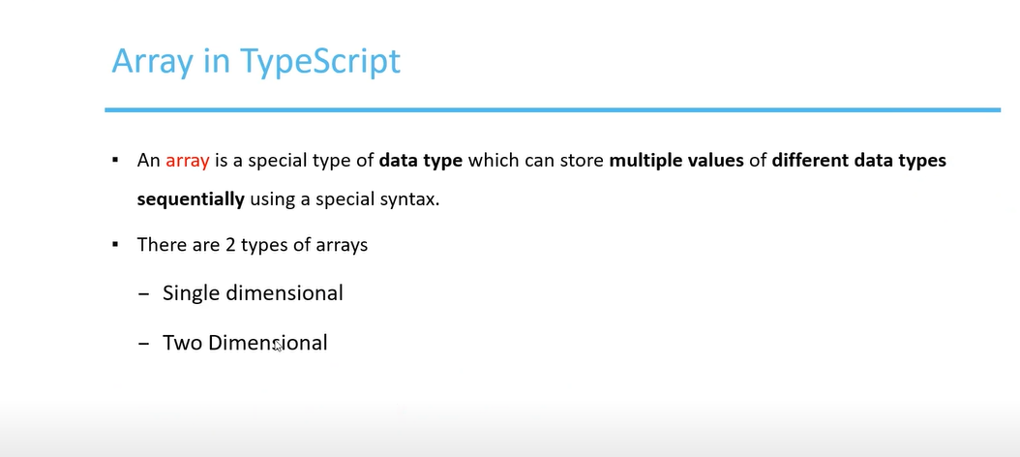

Declaring Arrays

In TypeScript Arrays are dynamic in nature (Sized is not fixed)

let num:number[]=[1,2,3];

let 🡪 declaring variables

num 🡪 declaring variable name

number 🡪 saying it’s a number array

other way

let num:number[]=new Array(5);

here, we are declaring array of length 5

other way (Generic way)

let num:Array<number>=new Array(); // dynamic array

other way

let num:Array<number>=new Array(1,2,3);

let num:Array<number>=new Array();

num[0]=1;

num[1]=2;

if we want to declare multiple values in array we need to use “or” operator to say it will store string or number

Declaring two dimensional array

Tupples

Tupple size is fixed it store different type of datax

Declaring tupple

let num:[number,string]=[1,"john"];

Declaring multiple tupples

let num:[number,string][]=[[1,"john"],[2,"smith"]];

Functions

Named Function: a function which has name is known as named function

**// anonymous function**

A function which doesn’t have name is known as anonymous function

**Types of Parameters declaration in functions**

1. **Optional parameters**

An **optional parameter** in TypeScript is a function parameter that is **not required** when calling the function.  
If you don’t pass a value for it, it will be undefined by default.

Declared using a? symbol after the parameter name.

1. **Default parameters**

A function parameter that has a predefined value if no argument is provided (or if undefined is passed).

So, if you don’t give a value, the default one will be used automatically.

Arrow functions

• Arrow functions are always **anonymous** (no function name unless assigned to a variable).

• They **do not have their own this**, which makes them behave differently in some contexts.

In typescript overloading the parameters should be different but should have same number of parameters

Classes And Objects

Difference between method and function in typescript

Function: it is define outside the class or without the class, it can be called any where directly

Method: It is define inside the class

Declaring Class in Class methods and objects are define

Inheritance

Interfaces

